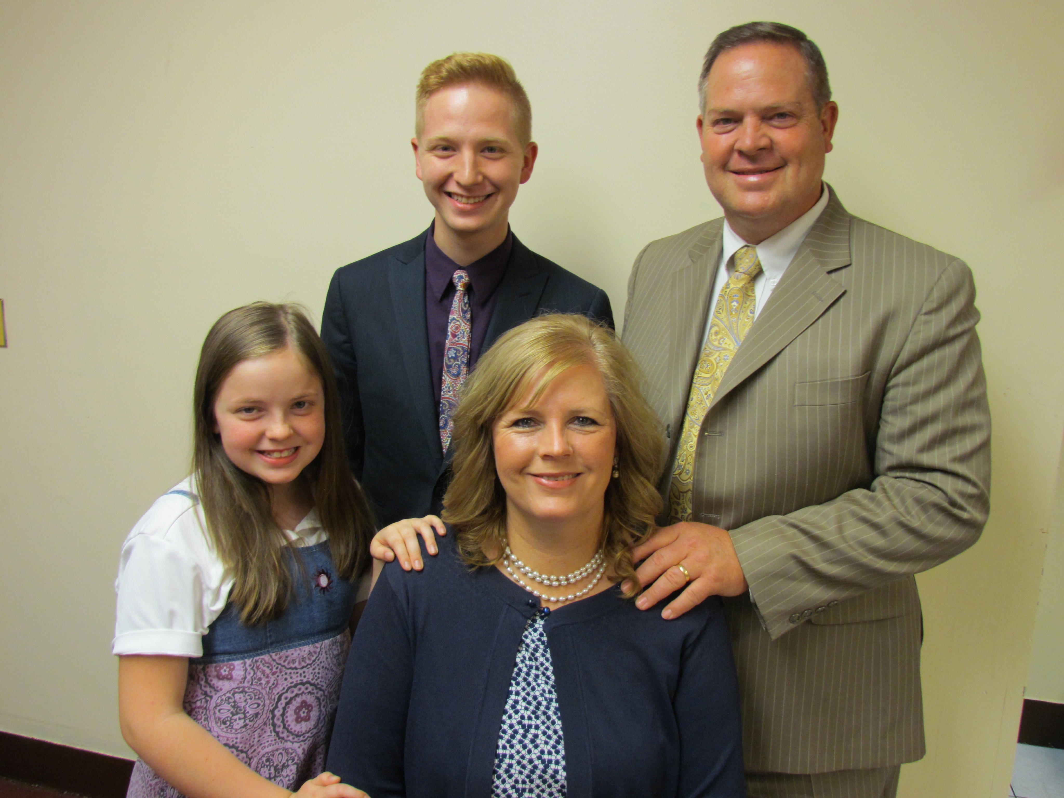
Dear Pastors, Churches, and Friends, April 11, 2019
The Dice Family
Church Planting Missionaries in New York City
W
e are into Spring now, passing a mild winter. We praise the Lord for His victory for us each day we live! We thank each of you for your prayers for us in this ministry unto the Lord reaching the people of Jamaica in NYC!
W
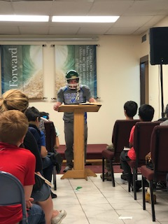
e have made some good contacts in door knocking and visiting. Our son-in-law Justin has been witnessing to a man whose wife is saved. He is Muslim in belief but allows his three children to come to our church. His oldest daughter gave a testimony saying, “I want my friends to know who the true God is.” She is only 8 years old. Pray for Mr. Waseem to be saved. Two of our college aged young people went into a building on a Saturday, and a doorman met them. He would not allow them to knock the doors but did allow them to put tracts on the doors. Once they finished one side of the building, they returned to the lobby ready to leave and the doorman said, “You can do the other side of the building as well.” It is getting harder to get into buildings in our area, and this was a special blessing. That same day I met a man in his forties. As I gave him a tract, he asked what it is about. I said, “It is about Jesus Christ.” As the conversation progressed, he told me he was a Voodoo priest. He certainly had a general knowledge of the Bible, and I was to witness to him about our Saviour. Pray for his salvation. We had Winter Camp for the children and teenagers the last of February with great attendance and new visitors. The messages were very helpful to all, and one teenage boy trusted Christ. It was great to have TJ Bradbury come and preach for us! On Sundays our children’s attendance has more than doubled since last August from our VBS, and also from this year’s Winter Camp!
O
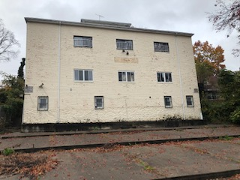
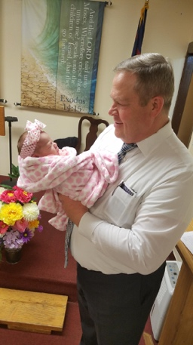
ur fundraising has gone well since our last letter! I was able to go to Colorado for the Dennis Brown Memorial Home Missions Conference! I am so encouraged by the powerful preaching! I presented our need and they raised $2500 for us. The same week was a church planting conference in New England, which I could not attend. Pastor Jim Townsley graciously offered to present our need in our place and $4000 was raised for us. We are so excited about what God is doing! Some churches and folks are supporting our building fund monthly, which can be used in the future to help with our mortgage. We are praying for additional support for 3 to 5 years to help us until we grow. We are now at $181,000 committed for the down payment. We were led to believe by one realtor that the building was in contract. But I received a call from Shri who has worked with us from the beginning, and he verified with the owner that the building is in fact not in contract! He told me the owner is not stuck on his asking price. I have been negotiating with them. The owner asked what we have in the bank currently, which is $154,000. This has caused him to hesitate, taking our offer seriously. I have asked them to consider 5% down for a contract. God is working in the owner’s heart and mind. Please continue to pray for God to move him to accept our offer at 1.2 million! Pray for the funding for a loan, and the down payment funds needed. We serve a mighty God who is able to do abundantly above all that we ask or think!!!
O
ur family is doing well! Our grandson Jace contracted the flu, mom and dad got it, and then we all got
it one by one! What a bout with flu! We had tiles falling off the wall in our upstairs bathroom, when I was at a conference. I decided it was time to fix the issues. I ended gutting our entire bathroom and start over from the studs. All is pretty well done now with just a few more things to complete. It was a happy day when the commode was set, and the shower was in operation for the Dice family! We had a new addition to our family! Our daughter Stephanie had their second child, Skye Elizabeth. So thankful for these grandbabies that come to visit and go home at night! Ha! We thank God for each of you that pray for our ministry and our family! Thank you for your faithful financial support!

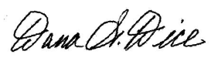
Sending Church: Clearview Baptist Church 10 Gospel Rd., Heber Springs, AR 72543 (501)362-5674
Mission Address: B.I.M.I. P.O. Box 9 Harrison, TN 37341 (423)344-5050
Field Address: 89-11 204th Street, Hollis, NY 11423 my cell (646)382-4583 e-mail danajulienyc@juno.com

