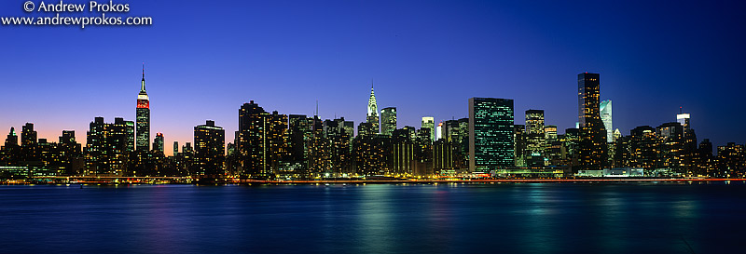
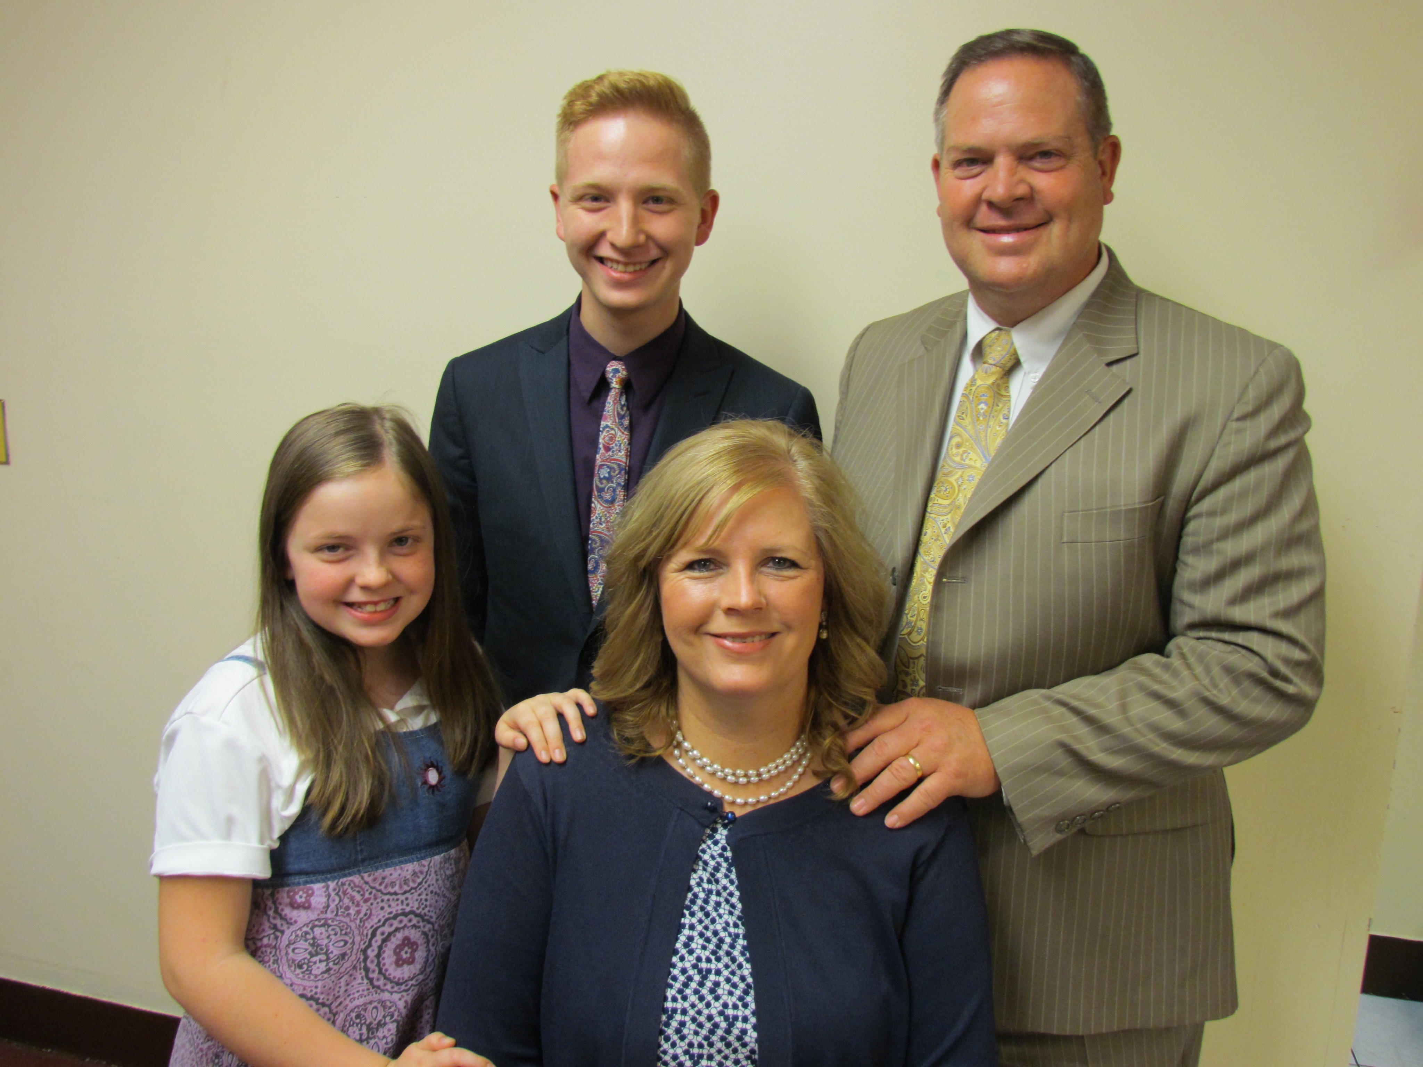
Dear Pastors, Churches, and Friends, January 28, 2019
The Dice Family
Church Planting Missionaries in New York City

W
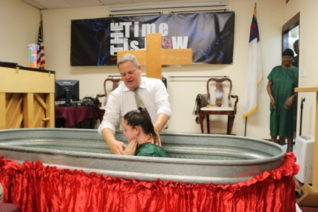
e want to give thanks to our heavenly Father for His goodness to us in so many ways! We have had a very mild winter here in New York City! We had a freak snow storm blow through on November 15, which paralyzed the city for hours. They were not prepared. We were driving into the storm to a Men’s Retreat, headed to Pennsylvania. We got stalled for 30 minutes with the traffic attempting to make the circle ramp approach to the Verrazano Narrows Bridge. Other than that snow, not much snow. It has made it easier on the over 12 million people!

W
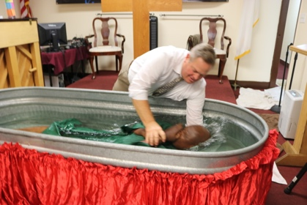
e baptized four in October! Three adults and our daughter, Esther! This this last Summer we spent a good deal of time knocking doors in South Hollis. As a result we have been able to bring three Pakistani Muslim children from a home there, and four more children from a family related to the mother. Ramesh is a young man of our church that attends Vision Baptist College. He was home for Christmas and preached one Sunday in Children’s Church. Four of those children trusted Christ that day and another girl whose family is from Guyana!

G
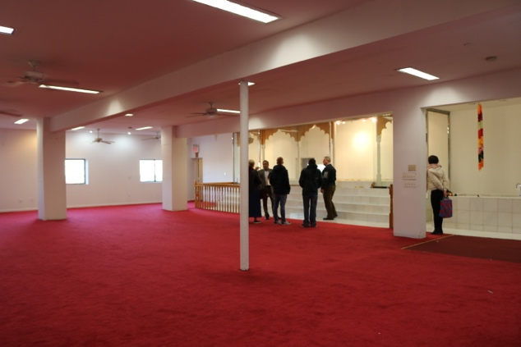
od has really blessed the fundraising for this Building! We are very grateful to the pastors, churches, and individuals that have helped us so far! We began the end of November with $64,000 and now are at $148,000! We need $112,000 more to have 20% down, which includes closing costs. I was able to attend the Heartland Church Planting Conference in Oklahoma City, and they raised over $25,000 for us! We are planning to attend two more conferences in March. Please pray for us to raise the remaining funds needed for a down payment. I am working with a broker who is seeking funding for a mortgage. We need prayers for the mortgage, and also for the owner to accept our offer! I am keeping in contact with the realtor. I am also asking each pastor and each church to prayerfully consider helping us with our down payment! In our Jamaica area there are 16 Catholic Churches, 15 Hindu Temples, 18 Muslim Mosques, 12 Seventh Day Adventist Churches, and 12 Kingdom Halls! We are the only Independent Baptist Church in Jamaica, NY! We want to secure a building and finish this work of making this an indigenous church for Christ!

T
hank you to those who gave us love offerings, and cards during the Christmas season! We are encouraged by your thoughtfulness! All of us are enjoying good health! Nathanael is starting a new job and he bought a good car from his sister. Esther is now 13 years old, growing into a fine young lady. They both help us so much in the ministry. Nathanael taught his first Sunday School lesson this last Sunday to the Teens. Justin and Stephanie are awaiting the coming of their second child, a girl. She is due the last day of February, at the Lord’s timing for sure! We are grateful for your prayers and support financially enabling us to continue here in New York City! You can keep up with the fundraising of the building on our website at dicefamily.org.

In Christ,
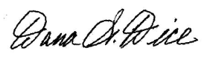
Sending Church: Clearview Baptist Church 10 Gospel Rd., Heber Springs, AR 72543 (501)362-5674
Mission Address: B.I.M.I. P.O. Box 9 Harrison, TN 37341 (423)344-5050
Field Address: 89-11 204th Street, Hollis, NY 11423 my cell (646)382-4583 e-mail danajulienyc@juno.com

