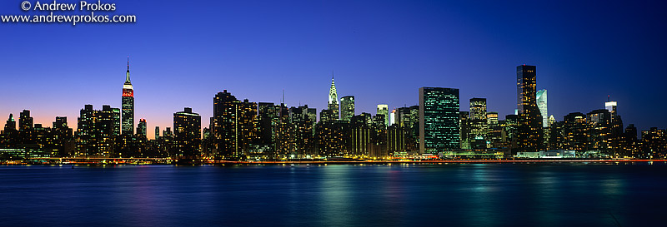
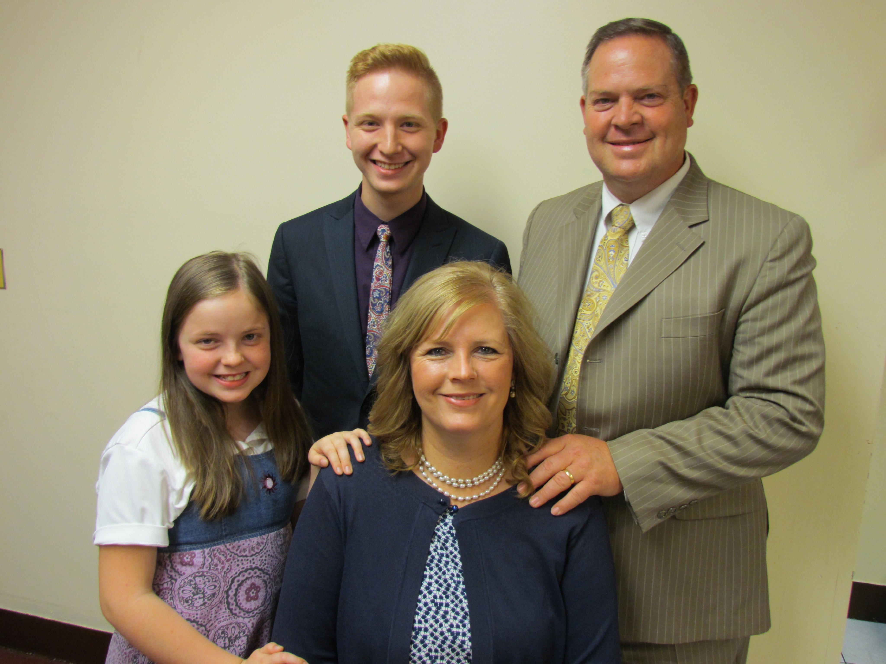
The Dice Family
Church Planting Missionaries in New York City
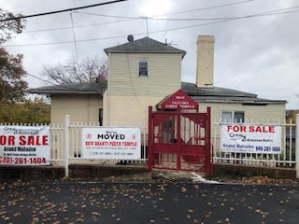
Dear Pastors, Churches, and Friends, November 26, 2018

We want to tell you about a building that we are asking God to give to Gospel Light Baptist Church of Jamaica, New York. This building has two main floors, each having a little over 2,100 square feet of space. The first floor from the street level is the main auditorium, which is 35' x 60'. It also has a hallway behind it and a room to the side that would make a great office. The lower floor has a smaller auditorium of about 30' x 40'. It also has a kitchen, two more rooms, three bathrooms, and some perimeter hallways. Above the main floor is an apartment that could house a single adult or a couple. At the back of the building under the lower auditorium is another apartment across the length of the building with two separate entry doors. The entire lot is 50' wide and 177' feet long. The Certificate of Occupancy is on file and valid, and the building is already off the real estate tax rolls.

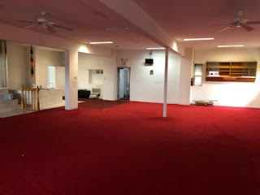
The list price is 1.49 million. We have made an offer to the owner in the amount of 1.2 million. The owner has not accepted our offer at this writing, but we believe with God’s help, the owner will accept our offer. When that happens, we would need to immediately seek financing. Rather than wait, we are now taking steps to get preapproved for a mortgage loan. We ask for your prayers and for your help financially to obtain this building. Currently, our church has $50,000 in the bank with an additional $14,000 in an annuity. We need to have a 20% down payment, which will amount to $240,000. We are adding an additional $20,000 for closing costs. With what we have saved and we have on hand, we will need to raise an additional $196,000. Yes, we need a miracle, but our God is a miracle God! We ask you to pray with us about this building? While we wait for the owner to approve our offer and while we seek financing, we would ask you to consider helping us with this project. The illustration below would not get us to our final amount needed but it would get us so much closer to what we must have to obtain a permanent building.

If 75 churches would give $1,000 each, it would amount to $75,000.

If 150 churches would give $500 each, it would amount to $75,000.

If 184 churches would give $250 each, it would amount to $46,000.

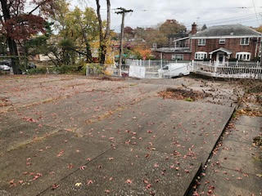
Gospel Light Baptist Church is a church we started. Our people are excited and praying for God to work a miracle! On November 18, we gave $1,400 towards the building fund for this building. We need God's help and we need the help of God's churches to give us a permanent building in which to grow! It has everything we have prayed for and it is located one mile away from our current location, one block off the same busy avenue! God says, "Call unto me, and I will answer thee, and shew thee great and mighty things, which thou knowest not." Would you help us? You can contribute to our building fund two ways. Go to dicefamily.org and use PayPal. Or you can send a check to our mission agency and on the memo line put Dice Building Fund. Please direct your contribution to Baptist International Missions, Inc. (BIMI), PO Box 9, Harrison, TN 37341.

In Christ,
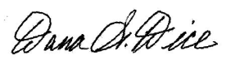
Sending Church: Clearview Baptist Church 10 Gospel Rd., Heber Springs, AR 72543 (501)362-5674
Mission Address: B.I.M.I. P.O. Box 9 Harrison, TN 37341 (423)344-5050
Field Address: 89-11 204th Street, Hollis, NY 11423 my cell (646)382-4583 e-mail danajulienyc@juno.com

Our Website - dicefamily.org

