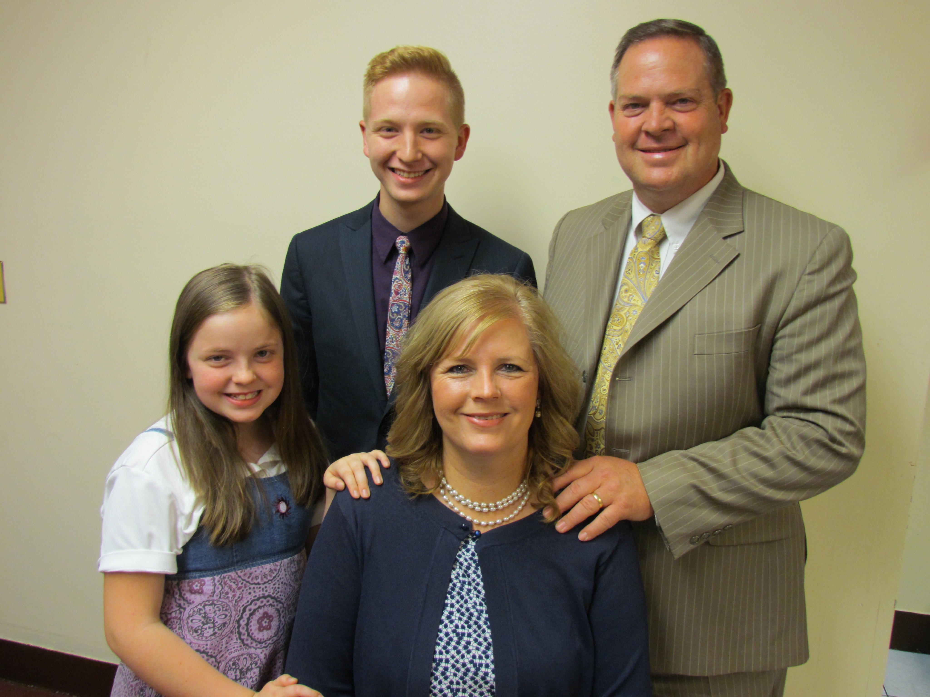
Dear Pastor, Church, and Praying Friends, September 11, 2018
The Dice Family
Church Planting Missionaries in New York City

W
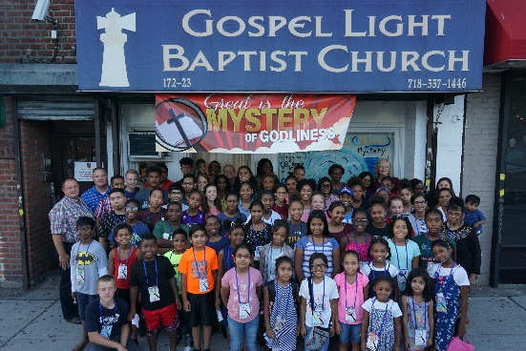
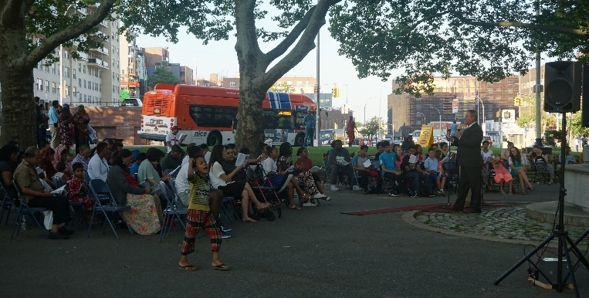
e want to give thanks to God for all that He has done this Summer in and through us! It has been busy and we schedule ourselves that way to get the most out of these months! We were able to take 14 teens to Teen Camp June 18-22. The last week in June is our Gospel Preaching in the Park event when we hold services each night with singing, testimonies of salvation, and two preachers speaking each night. Bro. James Hoffmeister and Bro. Bill Smith came to preach for us this year. This is our biggest event of the year. Last year the parks service asked us not to use a gas powered generator in the park any longer. So God provided through Bro. Bill Smith's home church in Ohio! He was given four commercial grade batteries that we could run a piano and a sound system on. With some powerful inverters we had full power! The Gospel was preached clearly! We had so much opposition, but God gave us help with local police patrolling and wisdom from God to work with those in the park that were drunk. Several nights you could see them pouring drinks from a bottle in a brown bag to a group encircled. We had several professions of faith, and many had the seed sown unto them. On Saturday morning I received a call from Daisy, a lady in our church. I could tell her voice was shaky and emotional. She began to tell me that she was reading a devotional regarding Revelation 3:20. She understood only she could open the door and receive Christ as Saviour, and she did just that! We have taken two main areas to knock doors in this Summer. Each of these is distinctly different; one more affluent and the other in the projects. The projects has given us the opportunity to reach a family with several children and teens. Tyara and Lynasia have been coming, and their brother came for our Vacation Bible School. God works in people's lives if we will go and compel them!
I
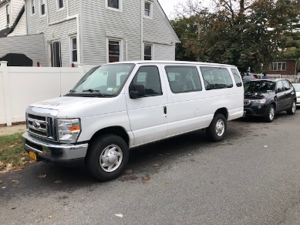
n August I took 2 boys and 5 girls to Junior Camp! It is great to see God working in their hearts to love the Lord more and to grow in their understanding of the Bible. Following camp we had our Vacation Bible School. Bro. Smith came again with his family and this year's theme was Great Is The Mystery from I Timothy 3:16. William Tyndale's life was used for the Missionary Story! What a helpful combination for our young people to learn and understand about God's Word! We had some new individuals in our church help in classes, and help our veteran teachers. Rafael was teaching in the Junior class one day, saying that most had heard about how Jesus Christ had died for our sins. Alyia said to Julie, my wife, "I have never heard of this before." She and her family moved to NYC from Barbados: they are Hindus. We had two boys who really struggled with the Bible because one was from Haiti and the other Pakistan. The English language is foreign to them. What great opportunities we have to work with people who need to learn who God really is!! We were able to purchase a used 2009 Ford van to transport people. We are grateful for your continued support which enables us to financially purchase a van, maintain it, and pay for the fuel to do the Lord's work!
E
arly in August our family was able to travel to Colorado to see Julie's mom! Her dad died April 16, but we were not all able to go at that time. Two of our three older children living in Oklahoma City came with their families. We enjoyed being an encouragement to Julie's family in remembering her dad. Nathanael is starting some online college courses this fall. Esther, our baby girl, is growing up, and is starting 7th grade this year! Sheila, my sister, is doing well and serving strong for the Lord. She is such a blessing to all of us! Julie and I are doing well! Our health is well and we praise God for the strength He gives. Thank you for praying for us as we continue to serve the Lord in this tremendously needy mission field. Pray for laborers to come start churches here! We are still praying for a building and seeking the Lord's direction!

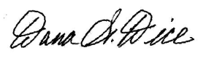
Sending Church: Clearview Baptist Church 10 Gospel Rd., Heber Springs, AR 72543 (501)362-5674
Mission Address: B.I.M.I. P.O. Box 9 Harrison, TN 37341 (423)344-5050
Field Address: 89-11 204th Street, Hollis, NY 11423 my cell (646)382-4583 e-mail danajulienyc@juno.com

Our Website - dicefamily.org

